Muhammad Tanzil-Ur-Rehman

BCS211037

Lab 01

Task 01

.model small

.data

msg db "Tanzil-ur-Rehman ",0Dh,0Ah," $"

msg1 db "Muhammad Yamin Asif ",0Dh,0Ah," $"

msg2 db "BCS211037 ",0Dh,0Ah," $"

msg3 db "BC Computer Science ",0Dh,0Ah," $"

.code

main:

;print strings

mov ax,@data

mov ds,ax

mov ah,9

mov dx, offset msg

int 21h

mov ah,9

mov dx, offset msg1

int 21h

mov ah,9

mov dx, offset msg2

int 21h

mov ah,9

mov dx, offset msg3

int 21h

mov ah,4ch

int 21h

end main

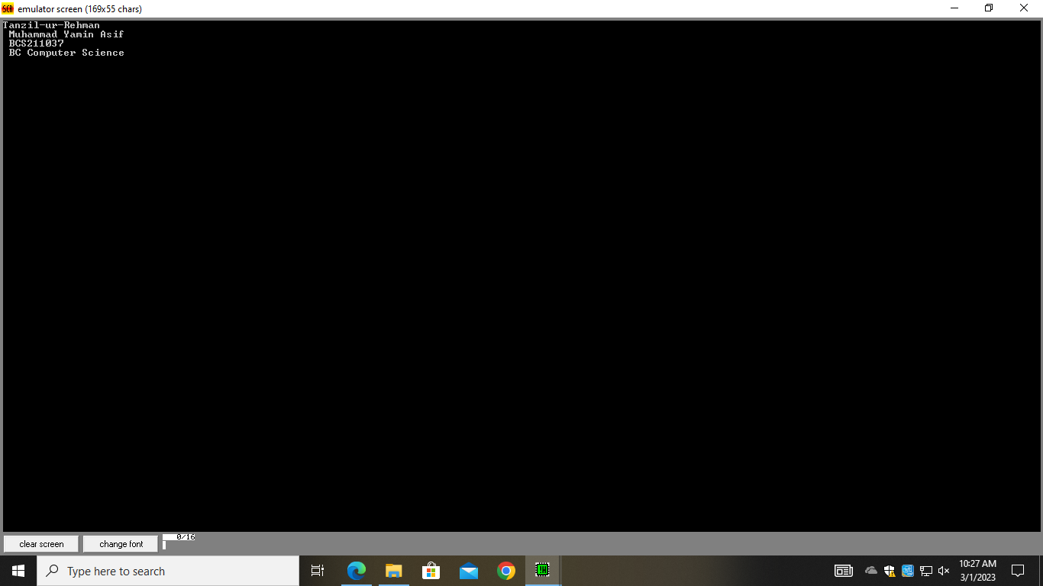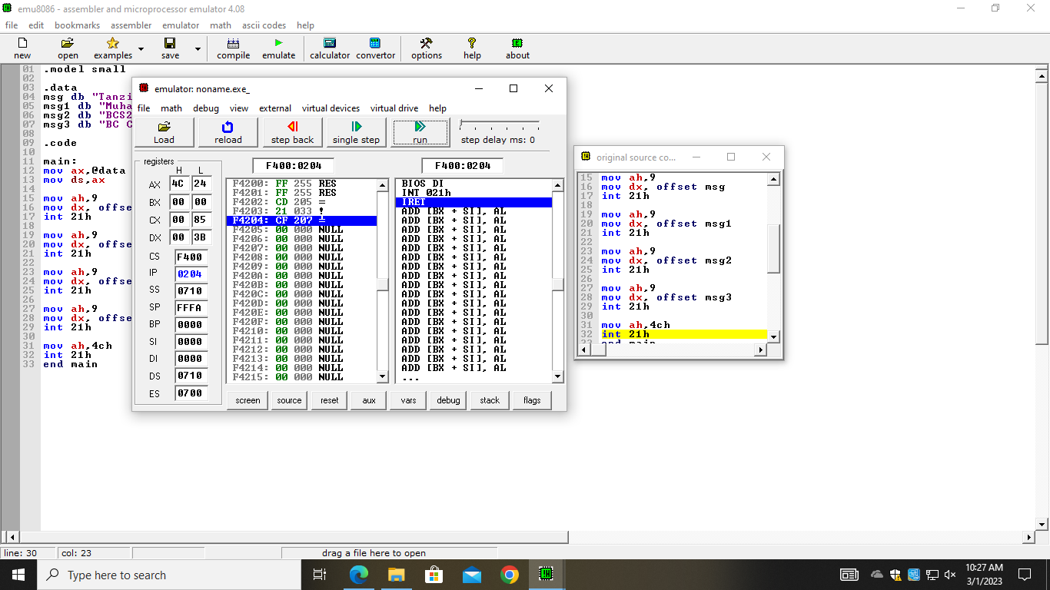

Task 02

.model small

.data

msg db "\*",0Dh,0Ah,"$"

msg1 db "\*\*",0Dh,0Ah,"$"

msg2 db "\*\*\*",0Dh,0Ah,"$"

msg3 db "\*\*\*\*",0Dh,0Ah,"$"

msg4 db "\*\*\*\*\*",0Dh,0Ah,"$"

.code

main:

;print strings

mov ax,@data

mov ds,ax

mov ah,9

mov dx, offset msg

int 21h

mov ah,9

mov dx, offset msg1

int 21h

mov ah,9

mov dx, offset msg2

int 21h

mov ah,9

mov dx, offset msg3

int 21h

mov ah,9

mov dx, offset msg4

int 21h

mov ah,4ch

int 21h

end main

